Energy from a wave
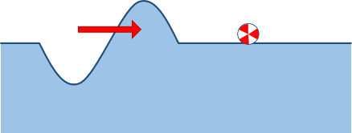
As the wave moves forward, it makes the ball move up and down.
The wave transfers energy to the ball.

a. Which wave transfers energy to the ball most quickly?
Put a tick (✓) next to the best answer.
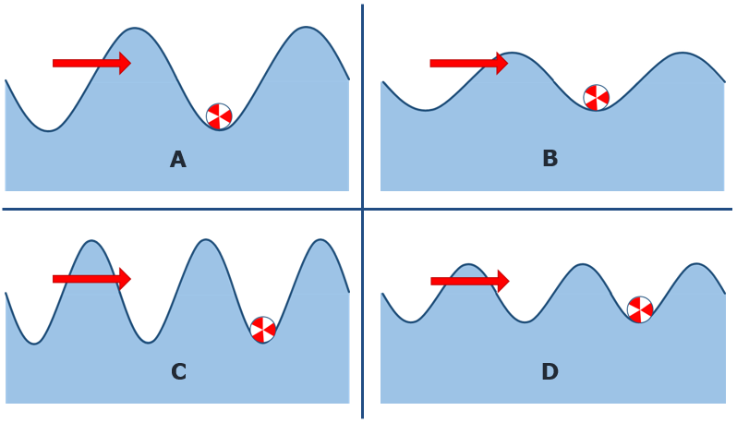
b. What is the best reason for your last answer?
Put a tick (✓) in the box next to the best answer.
A | This wave contains most water.
B | This wave makes the ball move most quickly.
C | This wave contains most energy.
D | This wave hits the ball with most force.

Physics > Big idea PSL: Sound, light and waves > Topic PSL4: Waves > Key concept PSL4.1: Waves on water and ropes
Diagnostic question
Energy from a wave

Overview
Learning focus: | A transverse wave travelling across the surface of water (or along a rope) transfers energy, as particles of water (or rope) are successively made to vibrate at right angles to the direction in which the wave travels.
Observable learning outcome: | Compare the amount of energy transferred by transverse waves that have different amplitudes or frequencies to each other and are moving through a common medium.
Question type: | Two-tier multiple choice
Key words: | Wave, transverse wave, amplitude, frequency, energy

B | BRIDGING  This diagnostic question probes understanding of ideas that are usually taught at age 14-16, to build a bridge to later stages of learning.

What does the research say?
When waves move through a medium students often describe the movement of some entity (perhaps mass, matter or force) through the medium. The scientific explanation involves no such movement. A wave moves forwards when a perturbation passes through a medium, and after it has passed the material of the medium returns to its original position. This is what distinguishes the motion of a wave from the motion of an object. (Fazio et al., 2008)
In a study of students enrolled onto a university physics course (Wittmann, Steinberg and Redish, 1999) some students explained that waves that had a bigger amplitude moved faster because they had been given more energy or more force when they were set going. It should be noticed that in a string any sideways force that produces the wave is not pushing along the direction of the wave and so does not accelerate the wave in the forwards direction. Any extra energy is observed by the greater side-to-side movement of the string as the wave progresses.
When talking about energy students tend to use science terms loosely: Driver et al. (1994) describe evidence from several researchers that students often confuse ideas of energy with ideas of force, work or power and may use the terms interchangeably. (Rogers, 2018) emphasises the importance of teachers modelling accurate use of science terms and advises giving students opportunities to practise using language precisely to help them develop an accurate model of what is happening.
Generally people think of energy as a substance, with flow and conservation analogous to that of matter. Although not scientifically correct this is considered an acceptable analogy (Millar, 2011). When explaining how energy is transferred, (Tracy, 2014) recommends that we focus on describing the processes and mechanisms involved. He suggests that trying to identify the ‘energy’ in each step is just a labelling exercise that can get in the way of a clear understanding of what is happening.

Ways to use this question
Students should complete the questions individually. This could be a pencil and paper exercise, or you could use an electronic ‘voting system’ or mini white boards and the PowerPoint presentation. The follow on question will give you insights into how they are thinking and highlight specific misconceptions that some may hold.
If there is a range of answers, you may choose to respond through structured class discussion. Ask one student to explain why they gave the answer they did; ask another student to explain why they agree with them; ask another to explain why they disagree, and so on. This sort of discussion gives students the opportunity to explore their thinking and for you to really understand their learning needs.
Differentiation
You may choose to read the questions to the class, so that everyone can focus on the science. In some situations it may be more appropriate for a teaching assistant to read for one or two students.
Expected answers
a. C
b. B
How to respond - what next?
For part a, most students are likely to choose either answer A or C because these waves contain more of ‘something’ and they clearly make the ball move up and down a greater distance. Answer A is perhaps more likely if students have the misunderstanding that energy is a substance that is transferred from the wave to the ball. This is because wave A has more bulk and visibly contains more water. Answer C is correct because this wave moves the ball up and down the greatest total distance in a fixed amount of time.
For part b answer A suggests the misunderstanding that water moves forward in a wave may persist. This forwards push on the ball is also hinted at in answer D. Answer C identifies students who think of energy as a substance carried by the wave, perhaps even as a material substance. Whilst it could be argued that all the answers are technically correct, answer B is the best reason because it describes the effect of the ball gaining the most energy.
If students have misunderstandings about the amount of energy transferred by transverse waves, with different amplitudes or frequencies to each other, that are moving through a common medium, it can help to reflect on how the movement of the ‘particles’ of water cause the movement of the ball. Careful questioning can elicit the understanding that the ‘particles’ in the wave move more quickly up and down if it has either a bigger amplitude or a higher frequency.
Giving students the opportunity to explain in their own words why more energy is transferred to the ball by wave C can consolidate learning and check individual understanding.
The following BEST ‘response activity’ could be used in follow-up to this diagnostic question:
- Response activity: Ripples on a pond

Acknowledgments
Developed by Peter Fairhurst (UYSEG).
Images: Peter Fairhurst (UYSEG).
References
Driver, R., et al. (1994). Making Sense of Secondary Science: Research into Children's Ideas, London, UK: Routledge.
Fazio, C., et al. (2008). Modelling Mechanical Wave Propogation: Guidelines and experimentation of a teaching-learning sequence. International Journal of Science Education, 30:11, 1491-1530.
Millar, R. (2011). Energy. In Sang, D. (ed.) Teaching Secondary Physics. London: Hodder Education.
Rogers, B. (2018). The big ideas in physics and how to teach them, 1 edn Abingdon and New York: Routledge.
Tracy, C. (2014). Energy in the new curriculum: an opportunity for change. School Science Review, 96(354), 11.
Wittmann, M. C., Steinberg, R. N. and Redish, E. F. (1999). Making Sense of How Students Make Sense of Mechanical Waves. The Physics Teacher, 37, 15-21.

